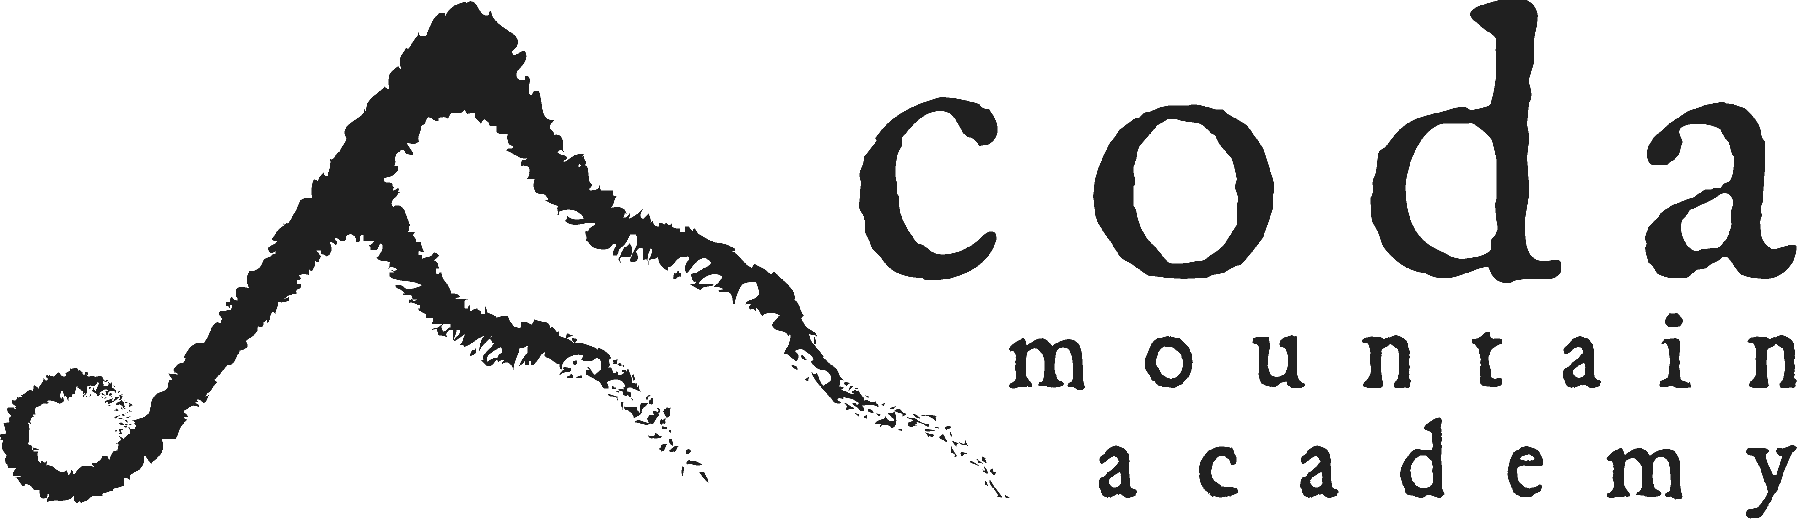

January 14, 2020

Dear Summer Music Festival friends,
Despite our sincere hope that the two week Coda Mountain Academy Summer Music Festival would return in 2020, we regretfully announce that this is not yet possible. It is very difficult to share this with you because of the excellence of this festival and the incredible people it brought together. I personally feel the loss of spending time with all of you.
Developing capacity necessary for sustainability and to support programs as robust as the SMF is a worthwhile but difficult process. The good news is that while there is much more work to be done, progress is being made to ensure that Coda programs can continue for many years to come!
We are deeply sorry that we are unable to execute the Summer Music Festival in 2020 and any unfulfilled expectations this may have caused. The memories shared, friendships enjoyed, lives changed, love/time/work invested into the SMF was an incredible gift to our lives, hearts and community. Although it is still too early in the process to know when it will be and how it will look, our hope is that in the future the SMF can be brought back as a viable and sustainable part of Coda Mountain Academy.
A special thank you to Julian and Marilyn Taylor, Robert Nicholson, the SMF board of directors and the outstanding and compassionate faculty for their incredible investment into so many of our lives. And to every student who has ever attended the festival, we continue to love you and believe in you. Our prayer is that your days at the SMF inspire and challenge you as you move forward into all you are destined to be and do. Please stay in touch!

Esther Morey
Executive Director
Coda Mountain Academy

